**CONFIGURATION**

1. Create New Role and Permission List for Voucher Approval
2. Permission List: AP000047

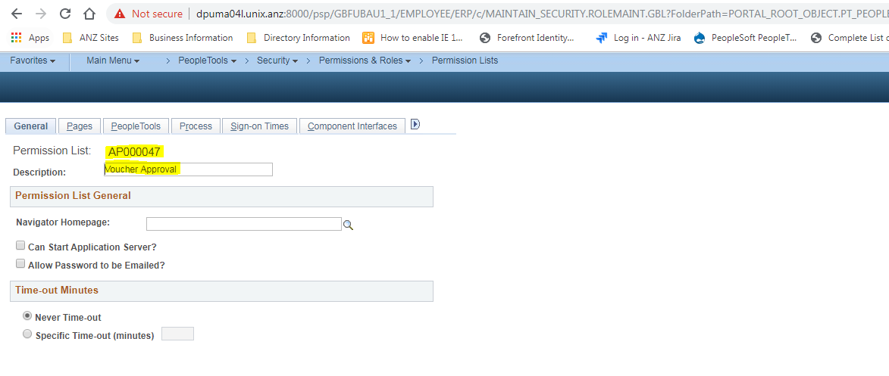

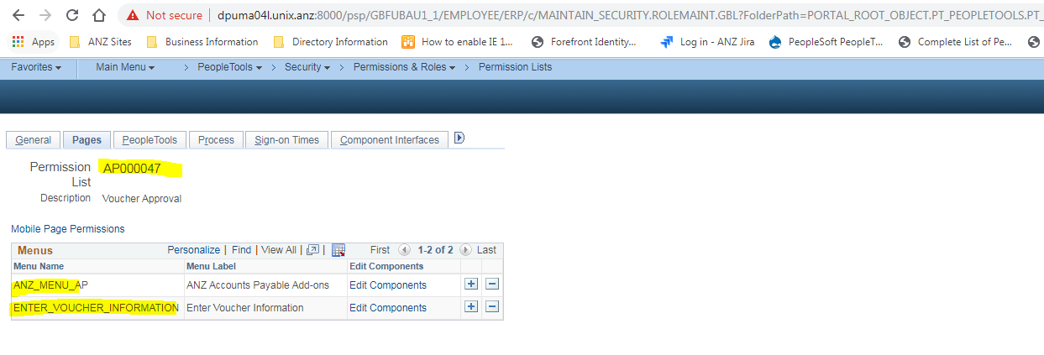

1. Role: AP000047 for Voucher Approval

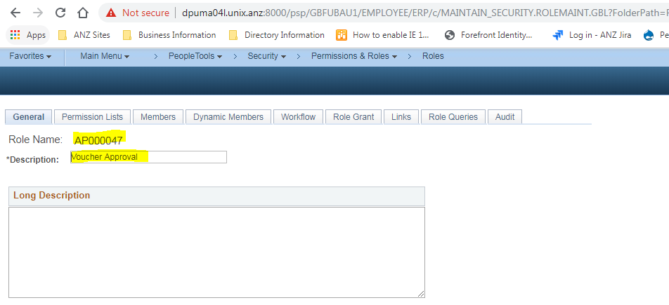

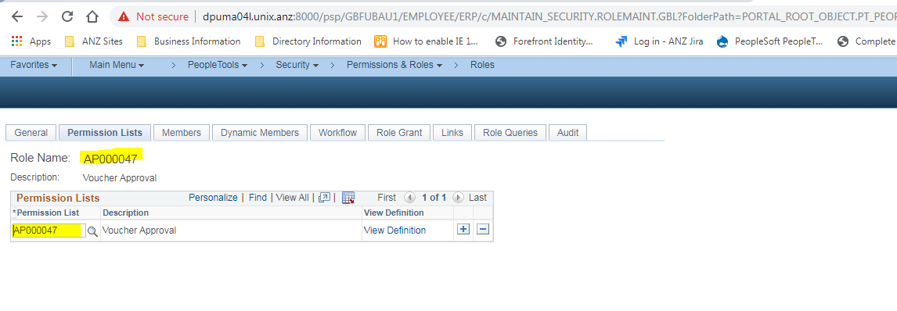

1. New Roles created for GST Control UK and QA Check UK
2. AP000045

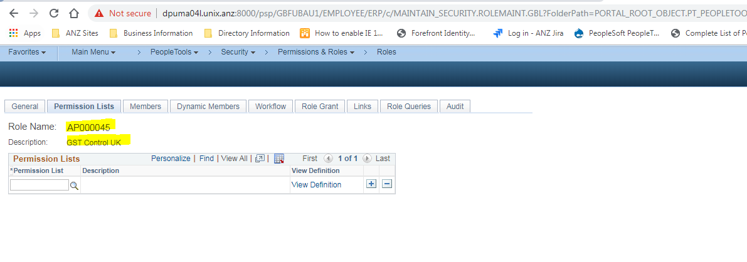

1. AP000046

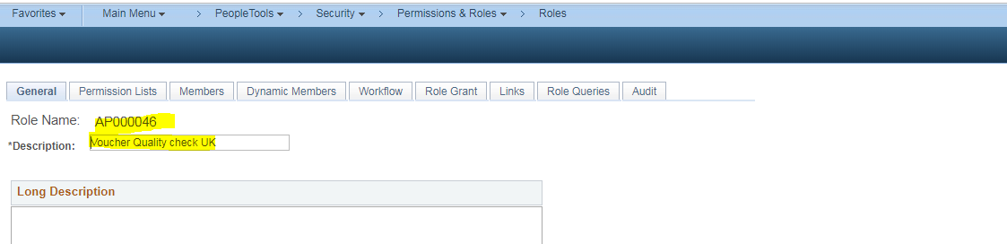

1. Assigned these roles to specific users who are responsible for GST Control and QA Check Approval for UK in following manner
2. GST Control
3. AP000045
4. AP000047
5. QA Check
6. AP000046
7. AP000047
8. New User Lists are created and assigned the respective roles to them.
9. GST_Control_UK

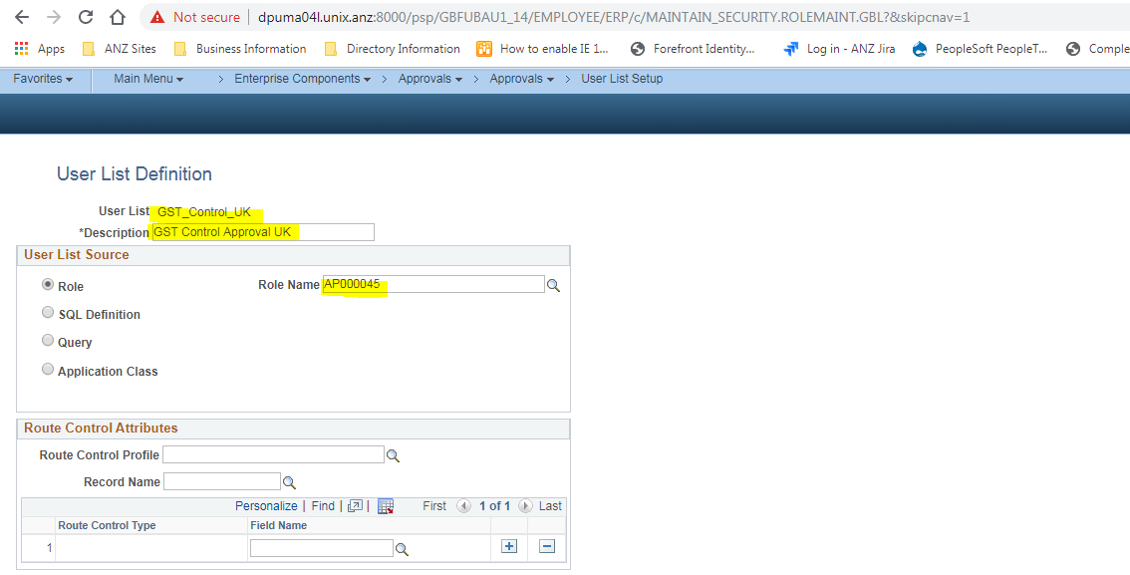

1. QA_Approval_UK

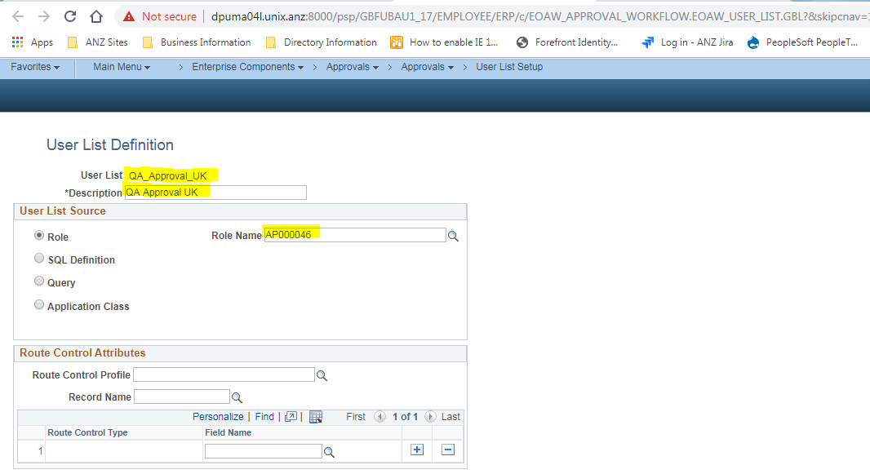

1. New AWE Setup for UK is configured

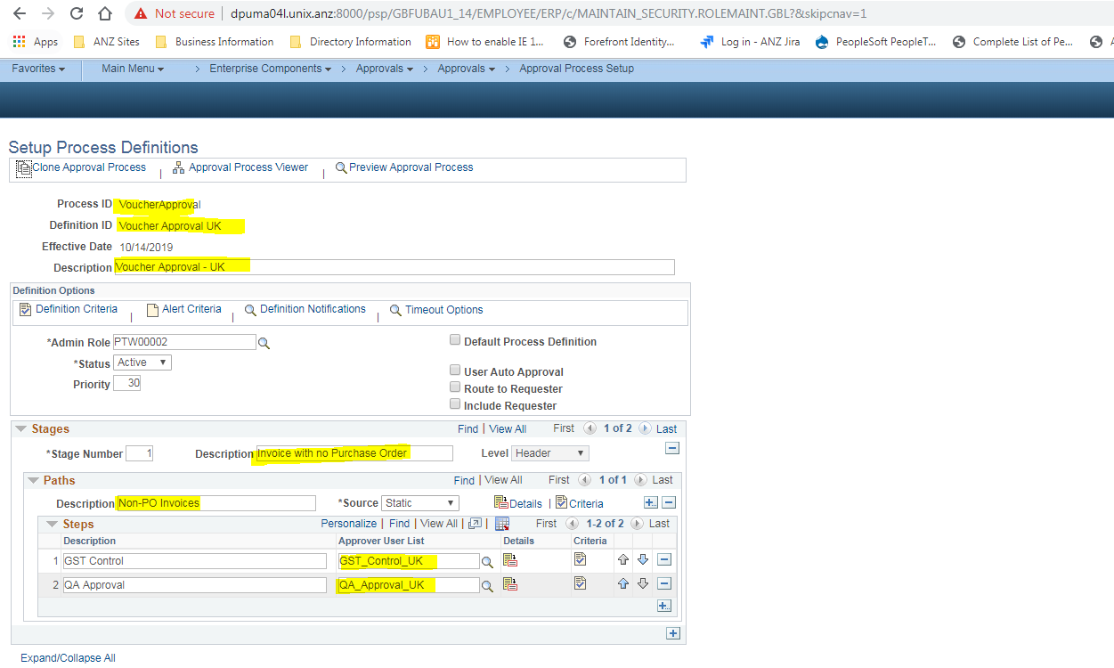

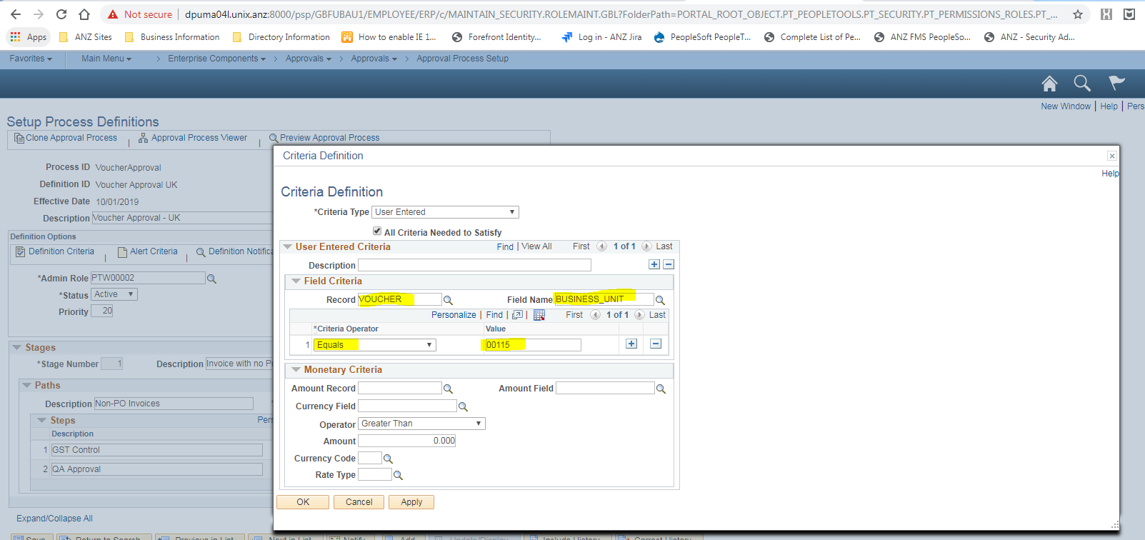

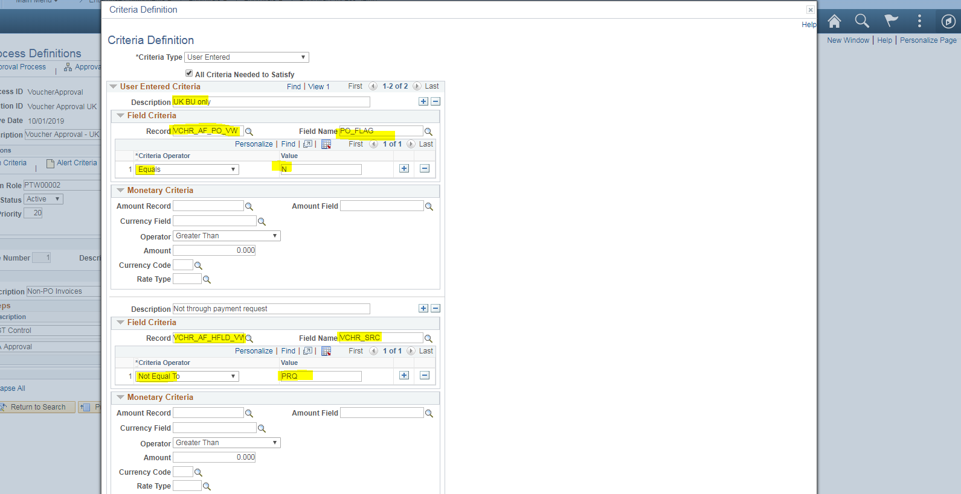

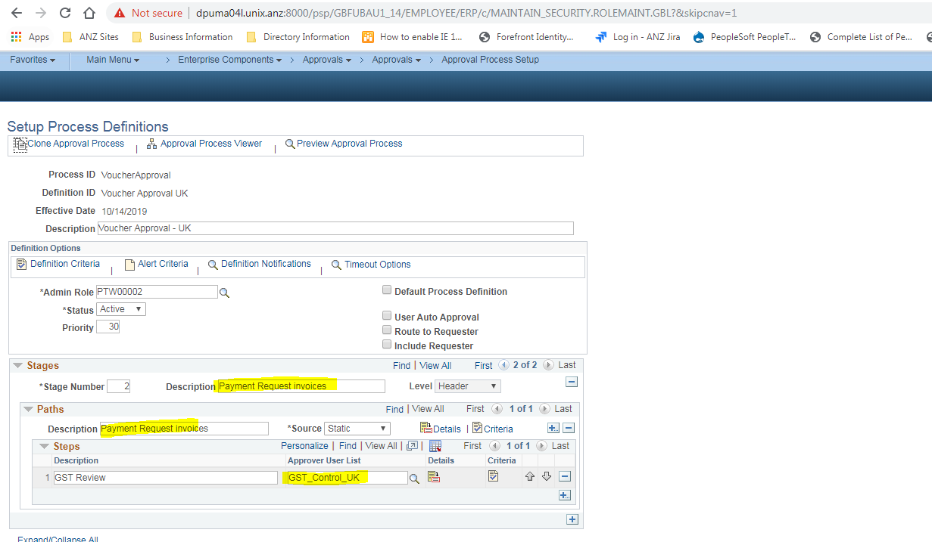

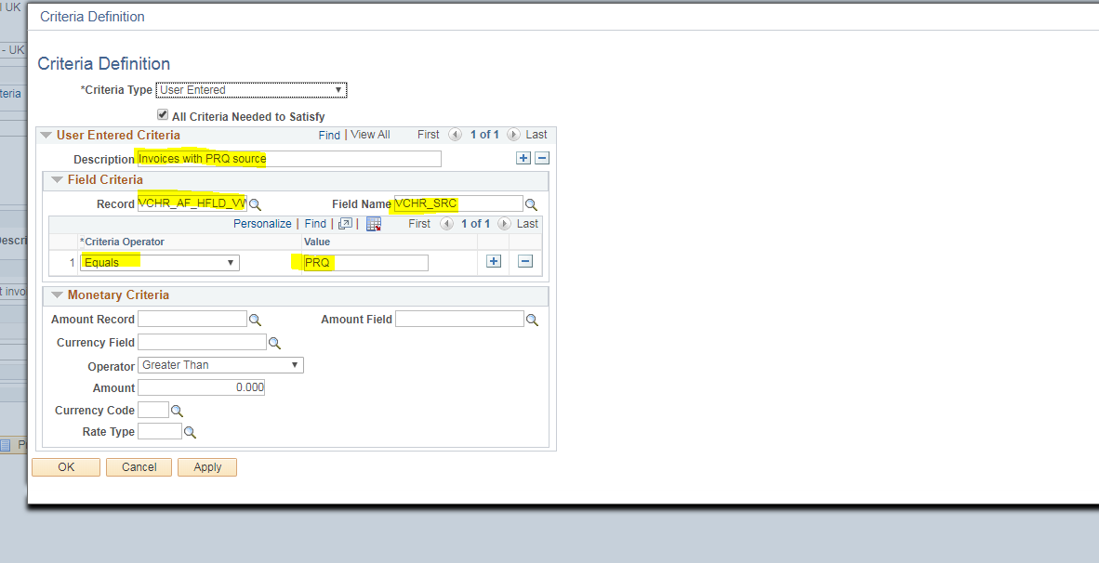

1. Changing Configuration in Payables Options

Voucher Approval to “Approval Framework”

